## **Front End Engineering-II**

Project Report

Semester-IV (Batch-2022)

**Random Quote Generator**



**Supervised By: Submitted By:**

Raveesh Samkaria Uday Singh Chauhan

2210990920

G-14

**Department of Computer Science and Engineering**

## **Chitkara University Institute of Engineering & Technology,**

## **Chitkara University, Punjab**

**Abstract**

In this project, we present a Random Quote Generator implemented with HTML, CSS, Bootstrap, and JavaScript. The goal of this web application is to display random quotes and their authors dynamically on a webpage, allowing users to discover and share inspiring or thought-provoking quotes.

The user interface is designed using HTML, styled with CSS and Bootstrap to achieve a clean and responsive layout. The JavaScript programming handles the logic behind fetching random quotes from an external API and updating the content dynamically without requiring a page reload.

Key features of the Random Quote Generator include:

* Displaying a visually appealing quote box with a randomized quote and author.
* Implementing a "New Quote" button to fetch and display a new random quote upon user interaction.
* Using asynchronous JavaScript (with fetch API) to retrieve quotes from the "https://type.fit/api/quotes" API.
* Toggling between front and back sides of the quote box for an engaging user experience.

The project leverages modern web technologies to provide a seamless and interactive experience for users interested in discovering inspirational quotes. It demonstrates foundational concepts of web development including DOM manipulation, asynchronous data fetching, and responsive design.

By exploring this Random Quote Generator project, developers can gain insights into building dynamic and data-driven web applications using HTML, CSS, Bootstrap, and JavaScript. The project serves as an educational resource for beginners and intermediate developers looking to enhance their skills in frontend web development and JavaScript programming.

**Table of Contents:**

* **Introduction**
* **Problem Definition & Requirements**
* **Proposed Design/Methodology**
* **Code**
* **Results**

**1. Introduction  
 1.1 Background**

The user interface design focuses on creating an engaging backdrop for the quotes using CSS and Bootstrap. A key element of the design is the background, which sets the tone for the overall aesthetic and enhances the user's experience.

The background of the Random Quote Generator is achieved through CSS styling, utilizing a linear gradient defined with the linear-gradient() function. This gradient transitions from one color to another, adding depth and visual interest to the webpage. Additionally, the background is designed to be responsive, adapting seamlessly to different screen sizes and devices.

The color scheme chosen for the background complements the overall theme of the project, enhancing readability and ensuring the quotes stand out prominently. The use of subtle animations and transitions further enhances the user interaction, making the Random Quote Generator both functional and visually appealing.

By exploring this project, developers can gain insights into effective background design using CSS gradients and responsive techniques. The project serves as a practical example of integrating design principles with frontend development, demonstrating how thoughtful background styling can elevate the overall user experience of a web application.

**1.2 Objective:**

The objective of this project is to develop a Random Quote Generator web application using HTML, CSS, Bootstrap, and JavaScript with a focus on achieving the following goals:

1. **Dynamic Content Display:**

Implement a webpage that dynamically displays random quotes and their authors without requiring a page reload. Utilize JavaScript to manipulate the Document Object Model (DOM) for seamless content updates.

1. **Responsive User Interface:**

Design a responsive and visually appealing user interface using CSS and Bootstrap. Ensure the layout adapts smoothly to different screen sizes and devices, providing a consistent experience across desktop and mobile platforms.

1. **API Integration:**

Integrate with an external API (specifically, "https://type.fit/api/quotes") to fetch a diverse collection of quotes. Use asynchronous JavaScript (with fetch API) to retrieve and parse JSON data from the API.

1. **Interactive Features:**

Implement interactive features such as a "New Quote" button that triggers the display of a new random quote upon user interaction. Enhance user engagement through subtle animations and transitions.

1. **Background Design:**

Employ CSS techniques to create an aesthetically pleasing background that complements the quote display. Use linear gradients and color schemes to enhance readability and visual appeal.

1. **Educational Value:**

Serve as an educational resource for developers learning frontend web development concepts. Demonstrate foundational skills in HTML, CSS, Bootstrap, and JavaScript, showcasing practical application of DOM manipulation and API integration.

**1.3 Significance:**

The development of a Random Quote Generator holds significant value in the realm of frontend web development, offering several key benefits and contributions:

**Interactive Learning Experience:**

Building a Random Quote Generator serves as an interactive and practical learning project for developers, especially those new to web development. It reinforces fundamental concepts of HTML, CSS, Bootstrap, and JavaScript while demonstrating real-world application through API integration and DOM manipulation.

**Demonstration of API Integration:**

The project showcases how to interact with external APIs to fetch and display dynamic content on a webpage. This demonstrates the importance of asynchronous programming in web development and exposes developers to working with data from external sources.

**Enhanced User Engagement:**

A Random Quote Generator is inherently engaging, providing users with fresh and inspiring content with each interaction. The inclusion of interactive features like a "New Quote" button and visually appealing design elements enhances user experience and encourages repeated usage.

**Focus on Responsive Design:**

By implementing responsive design principles using CSS and Bootstrap, developers learn how to create web applications that seamlessly adapt to various screen sizes and devices. This focus on responsive design is crucial for modern web development.

**Aesthetic Considerations:**

The project emphasizes the significance of background design and overall visual aesthetics in web development. The choice of color schemes, typography, and layout contributes to readability and user engagement, showcasing the importance of design in user interface development.

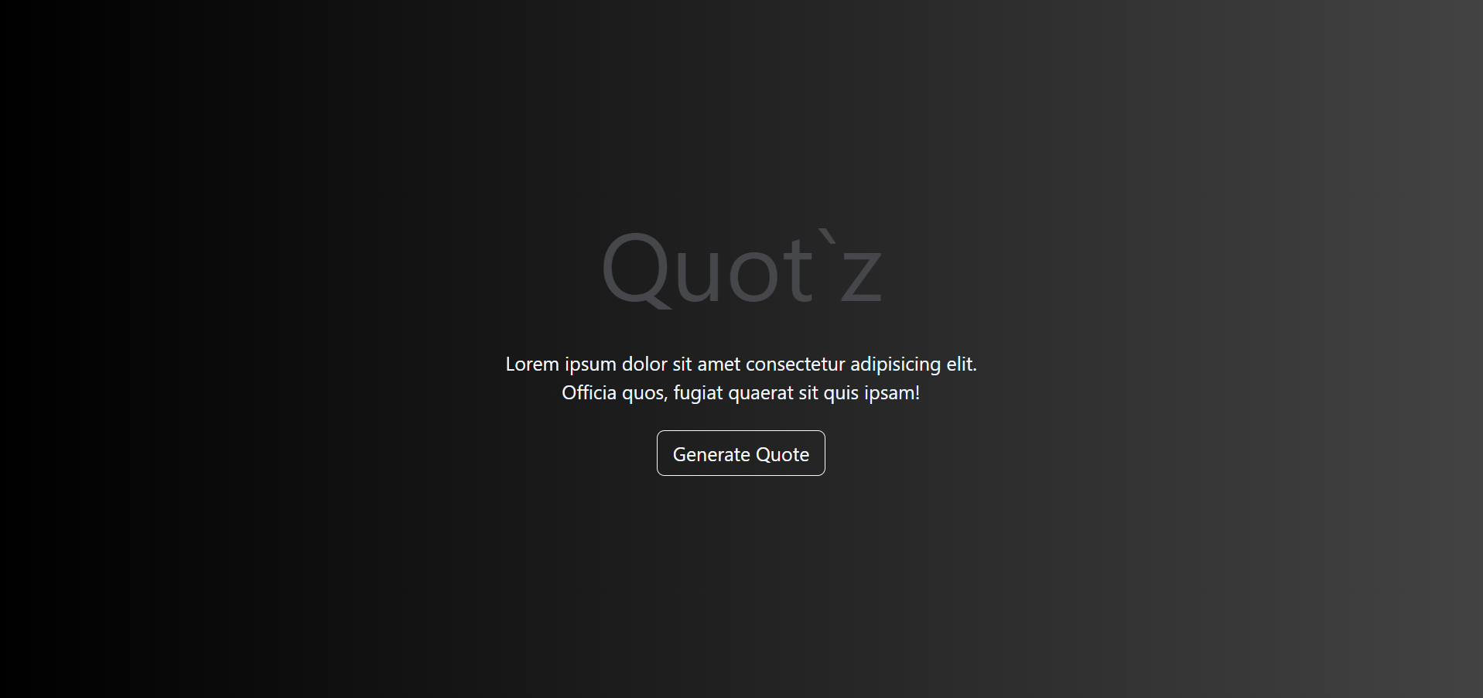

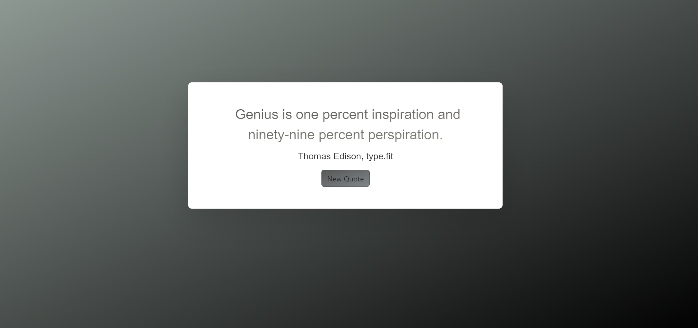

**2. Problem Definition & Requirements:**

**2.1 Problem Statement:**

Develop a Random Quote Generator web application using HTML, CSS, Bootstrap, and JavaScript. The application should display random quotes fetched from an external API and allow users to interactively retrieve new quotes with the click of a button. The project aims to provide an engaging user experience while demonstrating key concepts of frontend web development.

**Requirements:**

**User Interface Design:**

1. Create a visually appealing user interface using HTML, CSS, and Bootstrap.

2. Implement a quote display area with separate sections for the quote text and author.

3. Style the interface to be responsive and adaptable to different screen sizes.

**Quote Generation and Display:**

1. Use JavaScript to fetch random quotes from the "https://type.fit/api/quotes" API.

2. Display a random quote along with its author in the designated area on the webpage.

3. Ensure that the displayed quotes update dynamically without requiring a full page reload.

**Interactive Features:**

1. Include a "New Quote" button that triggers the display of a new random quote upon clicking.

2. Implement smooth transitions or animations when displaying new quotes to enhance user experience.

**Background Design and Aesthetics:**

1. Design an attractive background using CSS to complement the quote display.

2. Use CSS techniques such as linear gradients to enhance the visual appeal of the webpage.

**API Integration:**

1. Utilize asynchronous JavaScript (with fetch API) to make HTTP requests to the quotes API.

2. Parse the JSON response from the API to extract random quotes for display.

**Project Goals:**

The primary goal of this project is to demonstrate proficiency in frontend web development by building a Random Quote Generator application. By successfully completing this project, developers will achieve the following objectives:

* Gain hands-on experience in using HTML, CSS, Bootstrap, and JavaScript to create interactive web applications.
* Learn how to integrate external APIs into web projects for fetching and displaying dynamic content.
* Showcase skills in responsive design, user interface development, and asynchronous programming.
* Develop a portfolio-ready project that can be shared with potential employers or collaborators in the web development field.

**2.1.1 Software Requirements:**

The software requirements for the Random Quote Generator project are as follows:

**Web Browser:**

* The Random Quote Generator website is designed to run on modern web browsers, including Google Chrome, Mozilla Firefox, Safari, and Microsoft Edge.
* Ensure the web browser supports the latest web standards and JavaScript functionality.

**Code Editor:**

* Use a code editor for developing and editing HTML, CSS, and JavaScript files.
* Recommended code editors include Visual Studio Code, Sublime Text, Atom, Brackets, or any preferred editor with syntax highlighting and code completion features.

**Version Control System :**

* Employ a version control system like Git for managing project files, tracking changes, and facilitating collaboration.
* Platforms like GitHub or GitLab can be used for hosting repositories and managing project versions.

**Bootstrap:**

* Utilize Bootstrap framework for styling the user interface components of the Random Quote Generator.
* Ensure Bootstrap CSS and JavaScript files are included or linked within the project for responsive layout and component styling.

**Operating System:**

* The Random Quote Generator project can be developed and executed on various operating systems, including Windows, macOS, and Linux.
* Ensure the chosen code editor and web browser are compatible with the operating system being used.

**Internet Connection:**

* Maintain an internet connection for accessing Bootstrap documentation, downloading necessary dependencies (e.g., Bootstrap files), and testing the Random Quote Generator in a web browser environment.
* Online access is also required for fetching quotes from the external API (e.g., "https://type.fit/api/quotes") during development and testing phases.

**2.1.2 Hardware Requirements**

The hardware requirements for running and developing the Random Quote Generator project are relatively minimal and include the following:

* + - **Processor:** A multi-core processor, such as an Intel Core i5 or AMD Ryzen equivalent, is recommended for optimal performance during development and testing.
    - **Memory (RAM):** A minimum of 4 GB of RAM is recommended for running development tools, code editors, web browsers, and other software concurrently.
    - **Storage:** Sufficient storage space is needed to store project files, code, assets, and dependencies. A solid-state drive (SSD) is preferred for faster read/write speeds and improved performance.
    - **Input Devices:** A keyboard and mouse (or trackpad) are essential for interacting with the computer and navigating the development environment.
    - **Internet Connection:** An internet connection is required for accessing documentation, downloading dependencies, and testing the Random Quote Generator in a web browser environment.

**3.Proposed Design/Methodology**

**3.1 Design Concept**

**Clean and Minimalist Layout:** The interface will feature ample white space and strategic placement of elements to maintain a clutter-free appearance, directing the user's focus towards the quote content.

**Typography Emphasis:** Careful selection of a legible and visually appealing font will be used to present the quotes. Variations in font sizes, weights, and styles will be leveraged to emphasize the quote itself and enhance overall readability.

**Colour Scheme:** A calming and harmonious colour scheme will be employed to evoke a sense of tranquillity and inspiration. Contrast will be carefully considered to ensure readability, particularly between text and background elements.

**Responsive Design:** The design will incorporate responsive principles to guarantee accessibility across a range of devices. Media queries and viewport units will be used to adapt layout and typography based on screen size.

**Dynamic Quote Display:** Animations or transitions will be implemented to smoothly display new quotes upon user interaction, contributing to a seamless and enjoyable user experience.

**Interactive Elements**: Prominent interactive elements, such as a "Generate Quote" button, will provide users with intuitive controls to trigger the display of a new random quote. Visual feedback, including button hover effects, will enhance usability.

**3.2 Methodology:**

The methodology for developing the Random Quote Generator project involves a systematic approach to designing, implementing, and testing the web application. Below are the key steps and methodologies to be followed:

**Requirements Analysis:**

* Define clear objectives and requirements for the project, including functionalities such as displaying random quotes, fetching data from an API, and implementing user interaction features.
* Gather and document software requirements, user expectations, and design specifications.

**Planning and Design:**

* Plan the architecture and user interface design of the Random Quote Generator.
* Create wireframes or mockups to visualize the layout, components, and interactions.
* Decide on the use of Bootstrap for responsive design and styling components.

**Implementation:**

* Set up the project environment with necessary tools and dependencies.
* Write HTML markup to structure the webpage and define quote display areas.
* Use Bootstrap classes and components for styling and responsive layout.

**Testing and Debugging:**

* Conduct thorough testing to validate the functionality and performance of the Random Quote Generator.
* Use developer tools to debug and fix any issues related to HTML, CSS, or JavaScript code.

**Documentation and Refinement:**

* Document the project including setup instructions, usage guidelines, and code explanations.
* Refine the user interface based on feedback and usability testing.

**HTML**

**<!DOCTYPE html>**

**<html lang="en">**

**<head>**

**<meta charset="UTF-8">**

**<meta name="viewport" content="width=device-width, initial-scale=1.0">**

**<title>Quot`z</title>**

**<link rel="stylesheet" href="https://cdn.jsdelivr.net/npm/bootstrap@5.3.3/dist/css/bootstrap.rtl.min.css"**

**integrity="sha384-dpuaG1suU0eT09tx5plTaGMLBsfDLzUCCUXOY2j/LSvXYuG6Bqs43ALlhIqAJVRb" crossorigin="anonymous">**

**<style>**

**.sitename{**

**padding-top: 27vh;**

**font-size: 99px;**

**font-family: Jersey 25;**

**color:#45474B;**

**}**

**.para{**

**padding-top: 15px;**

**font-size: 20px;**

**color: aliceblue;**

**}**

**.btn{**

**margin-top: 25px;**

**}**

**</style>**

**</head>**

**<body>**

**<div class="outerframe " style="background-image: linear-gradient(to right, rgb(0, 0, 0),#434343); height:100vh">**

**<div class="sitename text-center fas">**

**Quot`z**

**<div class="para">**

**Lorem ipsum dolor sit amet consectetur adipisicing elit.<br>Officia quos, fugiat quaerat sit quis ipsam! <br>**

**<button type="button" class="btn btn-outline-light btn-lg" onclick="redirectToURL()">Generate Quote</button>**

**</div>**

**</div>**

**</div>**

**<script>**

**function redirectToURL() {**

**window.location.href = 'http://127.0.0.1:5500/2ndProject/Quotes%20Generator/newfile.html#';**

**}**

**</script>**

**</body>**

**</html>**

**<!doctype html>**

**<html lang="en">**

**<head>**

**<!-- Required meta tags -->**

**<meta charset="utf-8">**

**<meta name="viewport" content="width=device-width, initial-scale=1">**

**<link rel="stylesheet" href="style.css">**

**<!-- Bootstrap CSS -->**

**<link rel="stylesheet" href="https://cdn.jsdelivr.net/npm/bootstrap@5.3.3/dist/css/bootstrap.rtl.min.css" integrity="sha384-dpuaG1suU0eT09tx5plTaGMLBsfDLzUCCUXOY2j/LSvXYuG6Bqs43ALlhIqAJVRb" crossorigin="anonymous">**

**<title>Quotes</title>**

**</head>**

**<body>**

**<div class="block text-center">**

**<div class="quote-box block__main block__front">**

**<span class="quote">**

**<i class="fas fa-2x fa-quote-left"></i>**

**<span class="text">**

**Quote To be Displayed Here**

**</span>**

**</span>**

**<div class="author">**

**Author to be Displayed Here**

**</div>**

**<a class="new-quote btn btn-default" onclick="newQuote()">New Quote</a>**

**</div>**

**<div class="quote-box block__main block__back">**

**<span class="quote">**

**<i class="fas fa-2x fa-quote-left"></i>**

**<span class="text">**

**Quote To be Displayed Here**

**</span>**

**</span>**

**<div class="author">**

**Author to be Displayed Here**

**</div>**

**<a class="new-quote btn btn-default " onclick="newQuote()">New Quote</a>**

**</div>**

**</div>**

**<script src="https://cdn.jsdelivr.net/npm/bootstrap@5.3.3/dist/js/bootstrap.bundle.min.js" integrity="sha384-YvpcrYf0tY3lHB60NNkmXc5s9fDVZLESaAA55NDzOxhy9GkcIdslK1eN7N6jIeHz" crossorigin="anonymous"></script>**

**<script src="mainscript.js"></script>**

**</body>**

**</html>**

**CSS**

**body {**

**min-height: 100vh;**

**background-image: linear-gradient(to right bottom, #35483f8f, #010101);**

**}**

**.quote-box{**

**padding:3rem;**

**transition: 0.5s;**

**transition-timing-function: ease-in;**

**}**

**.text{**

**font-size:30px;**

**padding-left:10px;**

**transition: 0.5s;**

**transition-timing-function: ease-in;**

**font-family: 'Roboto', sans-serif;**

**background-image: linear-gradient(to right bottom, #000000a8, #534d3da8);**

**color: transparent;**

**-webkit-background-clip: text;**

**}**

**.quote{**

**transition: 0.5s;**

**transition-timing-function: ease-in;**

**}**

**.new-quote{**

**font-size:15px;**

**border-radius: 5px;**

**cursor:pointer;**

**padding-bottom: 8px;**

**padding-top: 9px;**

**margin-top: 5px;**

**background-image: linear-gradient(to right bottom, #000000a8, #3e484ca8);**

**}**

**.text-center{**

**text-align: center;**

**}**

**.new-quote:hover{**

**opacity: 0.6;**

**}**

**.author{**

**margin:10px;**

**font-size:20px;**

**transition: 0.5s;**

**transition-timing-function: ease-in;**

**font-family: 'Open Sans Condensed', sans-serif;**

**background-image: linear-gradient(to right bottom, #444a52,#241919);**

**color: transparent;**

**-webkit-background-clip: text;**

**}**

**p{**

**margin-top: 5px;**

**text-align: center;**

**position: absolute;**

**width: 100%;**

**top:21.5%;**

**}**

**.block {**

**perspective: 150rem;**

**position: absolute;**

**top: 25%;**

**left: 27%;**

**}**

**.block__main {**

**min-width: 45vw;**

**position: absolute;**

**transition: all .8s ease;**

**backface-visibility: hidden;**

**box-shadow: 0rem 1.5rem 4rem rgba(0, 0, 0, 0.15);**

**border-radius: .5rem;**

**background-image: linear-gradient(to right bottom, #ffffff,#ffffff);**

**}**

**.block__back {**

**transform: rotateY(180deg);**

**}**

**.rotateF{**

**transform: rotateY(-180deg);**

**}**

**.rotateB{**

**transform: rotateY(0deg);**

**}**

**JavaScript**

**var data;**

**let front = true;**

**const authors = document.querySelectorAll(".author");**

**const texts = document.querySelectorAll(".text");**

**const body = document.getElementById("body");**

**const button = document.querySelectorAll(".new-quote");**

**const blockFront = document.querySelector(".block__front");**

**const blockBack = document.querySelector(".block__back");**

**const authorFront = authors[0];**

**const authorBack = authors[1];**

**const textFront = texts[0];**

**const textBack = texts[1];**

**const buttonFront = button[0];**

**const buttonBack = button[1];**

**const displayQuote = () =>{**

**let index = Math.floor(Math.random()*data.length);**

**let quote = data[index].text;**

**let author = data[index].author;**

**if(!author){**

**author = "Anonymous"**

**}**

**if(front){**

**textFront.innerHTML = quote;**

**authorFront.innerHTML = author;**

**}else{**

**textBack.innerHTML = quote;**

**authorBack.innerHTML = author;**

**}**

**front = !front;**

**}**

**fetch("https://type.fit/api/quotes")**

**.then(function(response) {**

**return response.json();**

**})**

**.then(function(data) {**

**this.data = data;**

**displayQuote()**

**});**

**function newQuote(){**

**blockBack.classList.toggle('rotateB');**

**blockFront.classList.toggle('rotateF');**

**displayQuote();**

**}**

**4. Results**

**4.1 Screenshots**

